NAME: SAGARSUMAN P MANJHI SUBJECT: PYTHON PROGRAMMING LAB | PRACTICAL: 07 | BATCH : 04  SYBVOC :SEM-III (DS)
EXPERIMENT BASED ON OBJECT-ORIENTED PROGRAMMING (OOP)

AIM : To study and implement object-oriented programming concepts in Python by creating classes, objects, constructors, methods, inheritance, and encapsulation through a Vehicle Rental Management System.
LEARNING OBJECTIVE :
  - To understand the fundamentals of object-oriented programming.
  - To create classes and objects in Python.
  - To implement constructors and instance methods.
  - To understand inheritance and encapsulation.
  - To apply conditional statements and input validation.
  - To develop a simple Vehicle Rental Management System.
TOOLS :
Sr. No. | Name Of Resources | Specification | Quantity | Remarks
1. | Hardware | Computer (i5-i7) Ram (Min 16GB) | 1 | For All Practical
2. | Software | Python / IDLE / VS Code | 1 | For All Practical
THEORY :
Object-Oriented Programming (OOP) is a programming approach that organizes code using classes and objects. It helps represent real-world entities, improve code reusability, and organize programs into manageable components.
In this practical, a Vehicle Rental Management System is developed using a Vehicle class. Each vehicle has a name, model, and daily rental rate. The program displays available vehicles, accepts the user's selection and rental duration, and calculates the total rental charge.
Concepts Used
- Class: A blueprint for creating objects. The Vehicle class defines the properties and behavior of vehicles.
- Object: An instance of a class. Each car, bike, or van in the program is a Vehicle object.
- Constructor: The __init__() method initializes an object's attributes when it is created.
- Instance Variables: Variables such as self.name, self.model, and self.rent store individual vehicle details.
- Methods: Functions defined inside a class. The calculate_rent() method calculates the total rental charge.
- Inheritance: A mechanism through which one class acquires properties and methods from another class. It is an OOP concept but is not implemented in the supplied program.
- Encapsulation: The practice of grouping data and methods within a class and controlling access to data. The program groups vehicle data and rental calculation behavior inside the Vehicle class, but does not implement strict data hiding.
Source Code:
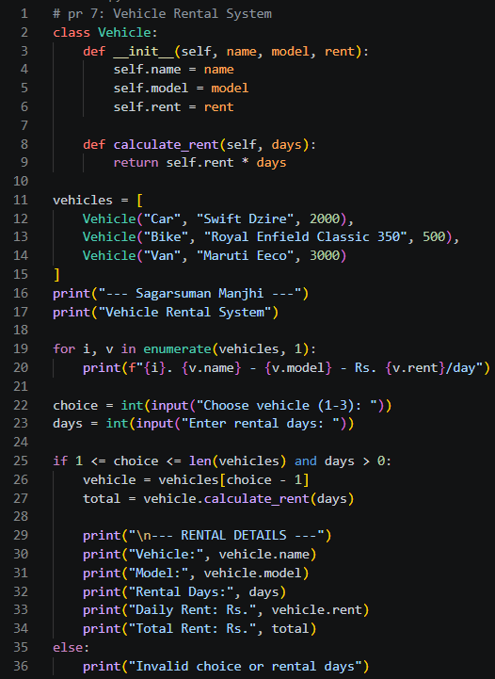
Output:
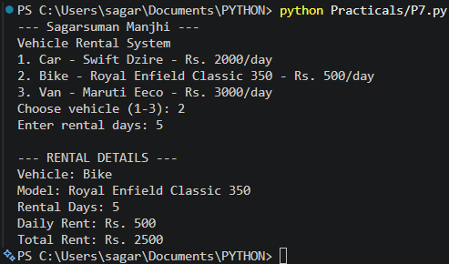
Result and Discussion:
The Vehicle Rental Management System was implemented successfully using Python classes, objects, constructors, and methods.
The program validates the selected vehicle number and ensures that rental days are greater than zero. Inheritance and advanced encapsulation are OOP concepts related to the experiment but are not directly demonstrated by this specific code.
Learning Outcomes:
- Learned to define classes and create objects in Python.
- Understood the purpose of constructors and instance variables.
- Applied conditional statements to validate user selections.
- Understood the role of inheritance and encapsulation in OOP.
- Developed a basic vehicle rental application using object-oriented programming.
Course Outcomes:
- Understand object-oriented programming concepts in Python.
- Create classes, objects, constructors, and methods.
- Apply object-oriented programming to solve practical problems.
- Develop a basic application using Python classes and objects.
CONCLUSION :
The Vehicle Rental Management System was developed successfully using object-oriented programming in Python. The program demonstrates classes, objects, constructors, instance variables, and methods to manage vehicle details and calculate rental charges. It also introduces the concepts of inheritance and encapsulation, which can be used to extend the application in the future.

VIVA QUESTIONS :
Q1. What is Object-Oriented Programming (OOP)?
OOP is a programming approach that organizes code around classes and objects.
Q2. What is a class in Python?
A class is a blueprint used to create objects.
Q3. What is an object?
An object is an instance of a class containing data and behavior.
Q4. What is a constructor in Python?
The __init__() method initializes an object when it is created.
Q5. What is the purpose of self?
self refers to the current instance of a class and allows access to its attributes and methods.

FOR FACULTY USE ONLY :
Correction Parameters | Formative Assessment [40%] | Timely completion of practical [40%] | Attendance/ Learning Attitude [20%]
Marks Obtained

